20

AGGREGATE DEMAND AND AGGREGATE SUPPLY

WHAT’S NEW IN THE SEVENTH EDITION:

There is a new In the News box on “What Have We Learned?”

LEARNING OBJECTIVES:

By the end of this chapter, students should understand:

➢ three key facts about short-run economic fluctuations.

➢ how the economy in the short run differs from the economy in the long run.

➢ how to use the model of aggregate demand and aggregate supply to explain economic fluctuations.

➢ how shifts in either aggregate demand or aggregate supply can cause booms and recessions.

CONTEXT AND PURPOSE:

To this point, our study of macroeconomic theory has concentrated on the behavior of the economy in the long run. Chapters 20 through 22 now focus on short-run fluctuations in the economy around its long-term trend. Chapter 20 introduces aggregate demand and aggregate supply and shows how shifts in these curves can cause recessions. Chapter 21 focuses on how policymakers use the tools of monetary and fiscal policy to influence aggregate demand. Chapter 22 addresses the relationship between inflation and unemployment.
The purpose of Chapter 20 is to develop the model economists use to analyze the economy’s short-run fluctuations—the model of aggregate demand and aggregate supply. Students will learn about some of the sources for shifts in the aggregate-demand curve and the aggregate-supply curve and how these shifts can cause recessions. This chapter also introduces actions policymakers might undertake to offset recessions.

KEY POINTS:

• All societies experience short-run economic fluctuations around long-run trends. These fluctuations are irregular and largely unpredictable. When recessions do occur, real GDP and other measures of income, spending, and production fall, and unemployment rises.

• Classical economic theory is based on the assumption that nominal variables such as the money supply and the price level do not influence real variables such as output and employment. Most economists believe that this assumption is accurate in the long run but not in the short run. Economists analyze short-run economic fluctuations using the model of aggregate demand and aggregate supply. According to this model, the output of goods and services and the overall level of prices adjust to balance aggregate demand and aggregate supply.

• The aggregate-demand curve slopes downward for three reasons. The first is the wealth effect: A lower price level raises the real value of households’ money holdings, which stimulates consumer spending. The second is the interest-rate effect: A lower price level reduces the quantity of money households demand; as households try to convert money into interest-bearing assets, interest rates fall, which stimulates investment spending. The third is the exchange-rate effect: As a lower price level reduces interest rates, the dollar depreciates in the market for foreign-currency exchange, which stimulates net exports.

• Any event or policy that raises consumption, investment, government purchases, or net exports at a given price level increases aggregate demand. Any event or policy that reduces consumption, investment, government purchases, or net exports at a given price level decreases aggregate demand.

• The long-run aggregate-supply curve is vertical. In the long run, the quantity of goods and services supplied depends on the economy’s labor, capital, natural resources, and technology, but not on the overall level of prices.

• Three theories have been proposed to explain the upward slope of the short-run aggregate-supply curve. According to the sticky-wage theory, an unexpected fall in the price level temporarily raises real wages, which induces firms to reduce employment and production. According to the sticky-price theory, an unexpected fall in the price level leaves some firms with prices that are temporarily too high, which reduces their sales and causes them to cut back production. According to the misperceptions theory, an unexpected fall in the price level leads suppliers to mistakenly believe that their relative prices have fallen, which induces them to reduce production. All three theories imply that output deviates from its natural level when the actual price level deviates from the price level that people expected.

• Events that alter the economy’s ability to produce output, such as changes in labor, capital, natural resources, or technology, shift the short-run aggregate-supply curve (and may shift the long-run aggregate-supply curve as well). In addition, the position of the short-run aggregate-supply curve depends on the expected price level.

• One possible cause of economic fluctuations is a shift in aggregate demand. When the aggregate-demand curve shifts to the left, output and prices fall in the short run. Over time, as a change in the expected price level causes perceptions, wages, and prices to adjust, the short-run aggregate-supply curve shifts to the right. This shift returns the economy to its natural level of output at a new, lower price level.

• A second possible cause of economic fluctuations is a shift in aggregate supply. When the short-run aggregate-supply curve shifts to the left, the effect is falling output and rising prices―a combination called stagflation. Over time, as perceptions, wages, and prices adjust, the short-run aggregate-supply curve shifts back to the right, returning the price level and output back to their original levels.

CHAPTER OUTLINE:

I. Economic activity fluctuates from year to year.

A. Definition of recession: a period of declining real incomes and rising unemployment.

B. Definition of depression: a severe recession.

II. Three Key Facts about Economic Fluctuations

A. Fact 1: Economic Fluctuations Are Irregular and Unpredictable

1. Fluctuations in the economy are often called the business cycle.

2. Economic fluctuations correspond to changes in business conditions.

3. These fluctuations are not at all regular and are almost impossible to predict.

Figure 1

4. Panel (a) of Figure 1 shows real GDP since 1965. The shaded areas represent recessions.

B. Fact 2: Most Macroeconomic Quantities Fluctuate Together

1. Real GDP is the variable that is most often used to examine short-run changes in the economy.

2. However, most macroeconomic variables that measure some type of income, spending, or production fluctuate closely together.

3. Panel (b) of Figure 1 shows how investment spending changes over the business cycle. Note that investment spending falls during recessions just as real GDP does.

C. Fact 3: As Output Falls, Unemployment Rises

1. Changes in the economy’s output level will have an effect on the economy’s utilization of its labor force.

2. When firms choose to produce a smaller amount of goods and services, they lay off workers, which increases the unemployment rate.

3. Panel (c) of Figure 1 shows how the unemployment rate changes over the business cycle. Note that during recessions, unemployment generally rises. Note also that the unemployment rate never approaches zero but instead fluctuates around its natural rate of about 5% or 6%.

D. In the News: The Social Influences of Economic Downturns

1. The U.S. economy suffered a severe economic downturn in 2008 and 2009.

2. This article from The New York Times examines how an event like this affects society as a whole.

III. Explaining Short-Run Economic Fluctuations

A. The Assumptions of Classical Economics

1. The classical dichotomy is the separation of variables into real variables and nominal variables.

2. According to classical theory, changes in the money supply only affect nominal variables.

B. The Reality of Short-Run Fluctuations

1. Most economists believe that the classical theory describes the world in the long run but not in the short run.

2. Beyond a period of several years, changes in the money supply affect prices and other nominal variables, but do not affect real GDP, unemployment, or other real variables.

3. However, when studying year-to-year fluctuations in the economy, the assumption of monetary neutrality is not appropriate. In the short run, most real and nominal variables are intertwined.

C. The Model of Aggregate Demand and Aggregate Supply
Begin by reviewing demand, supply, and equilibrium. Make it clear that the microeconomic variables of price and quantity can be aggregated into a price level (measured by either the GDP deflator or the Consumer Price Index) and total output (real GDP).


1. Definition of model of aggregate demand and aggregate supply: the model that most economists use to explain short-run fluctuations in economic activity around its long-run trend.

2. We can show this model using a graph.

Figure 2

a. The variable on the vertical axis is the average level of prices in the economy, as measured by the CPI or the GDP deflator.

b. The variable on the horizontal axis is the economy’s output of goods and services, as measured by real GDP.

c. Definition of aggregate-demand curve: a curve that shows the quantity of goods and services that households, firms, and the government want to buy at each price level.

d. Definition of aggregate-supply curve: a curve that shows the quantity of goods and services that firms choose to produce and sell at each price level.

3. In this model, the price level and the quantity of output adjust to bring aggregate demand and aggregate supply into balance.

IV. The Aggregate-Demand Curve

A. Why the Aggregate-Demand Curve Slopes Downward

Figure 3

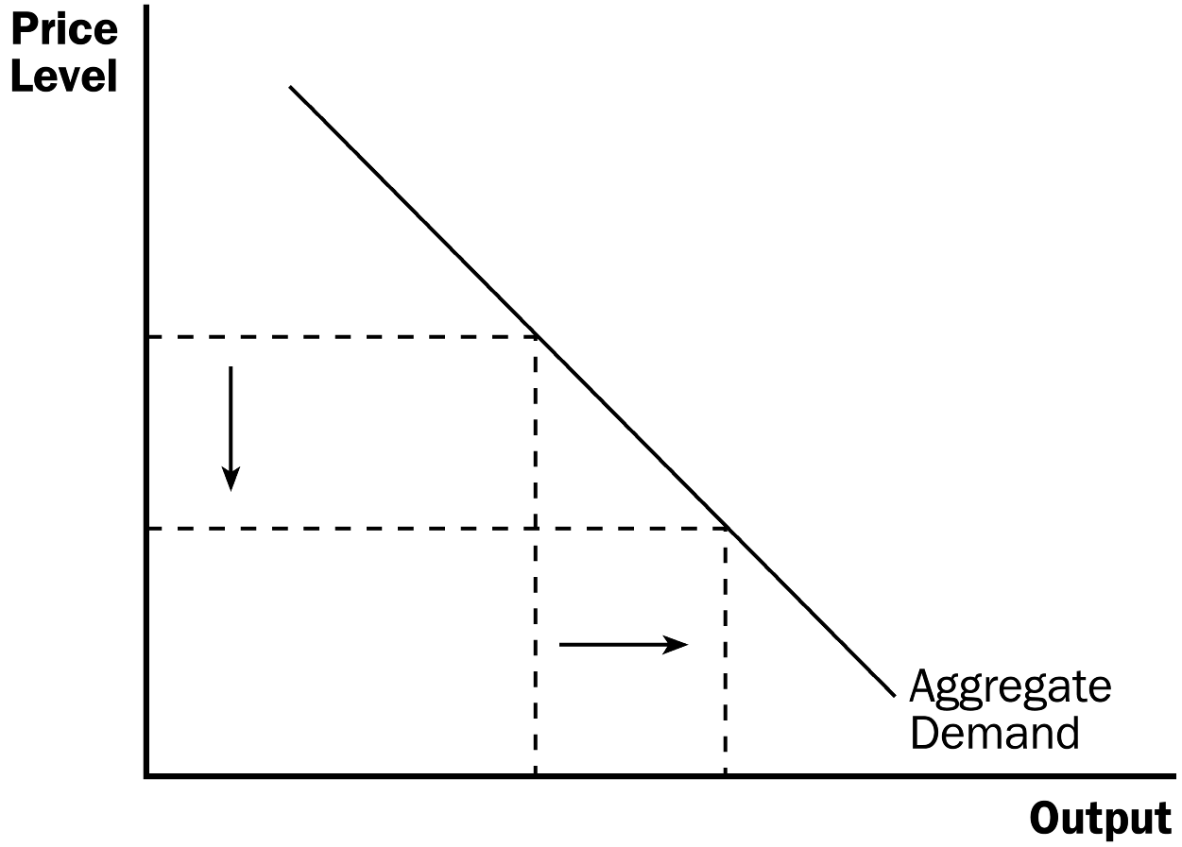

1. Recall that GDP (Y ) is made up of four components: consumption (C ), investment (I ), government purchases (G ), and net exports (NX ).
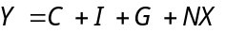

2. Each of the four components is a part of aggregate demand.

a. Government purchases are assumed to be fixed by policy.

b. This means that to understand why the aggregate-demand curve slopes downward, we must understand how changes in the price level affect consumption, investment, and net exports.


You will likely need to remind students of the difference between changes in quantity demanded (movements along the demand curve) and changes in demand (shifts in the demand curve).

Highlight the fact that all three of these effects begin with a decrease (or increase) in the price level and end with an increase (decrease) in aggregate quantity demanded.

3. The Price Level and Consumption: The Wealth Effect

a. A decrease in the price level raises the real value of money and makes consumers feel wealthier, which in turn encourages them to spend more.

b. The increase in consumer spending means a larger quantity of goods and services demanded.

4. The Price Level and Investment: The Interest-Rate Effect

a. The lower the price level, the less money households need to buy goods and services.

b. When the price level falls, households try to reduce their holdings of money by lending some out (either in financial markets or through financial intermediaries).

c. As households try to convert some of their money into interest-bearing assets, the interest rate will drop.

d. Lower interest rates encourage borrowing firms to borrow more to invest in new plants and equipment, and it encourages households to borrow more to invest in new housing.

e. Thus, a lower price level reduces the interest rate, encourages greater spending on investment goods, and therefore increases the quantity of goods and services demanded.

5. The Price Level and Net Exports: The Exchange-Rate Effect

a. A lower price level in the United States lowers the U.S. interest rate.

b. Some U.S. investors will seek higher returns by investing abroad, increasing U.S. net capital outflow.

c. The increase in net capital outflow raises the supply of dollars, lowering the real exchange rate.

d. U.S. goods become relatively cheaper to foreign goods. Exports rise, imports fall, and net exports increase.

e. Therefore, when a fall in the U.S. price level causes U.S. interest rates to fall, the real exchange rate depreciates, and U.S. net exports rise, thereby increasing the quantity of goods and services demanded.

6. All three of these effects imply that, all else being equal, there is an inverse relationship between the price level and the quantity of goods and services demanded.
Remind students that the aggregate-demand curve (like all demand curves) is drawn assuming that everything else is held constant.

B. Why the Aggregate-Demand Curve Might Shift
Get the students involved in suggesting factors that might shift the aggregate- demand curve. Relate changes in aggregate demand to changes in consumption, investment, government purchases, and net exports. Show students that, if any of these four components of GDP change (for reasons other than a change in the price level), the aggregate-demand curve will shift.

1. Shifts Arising from Changes in Consumption

a. If Americans become more concerned with saving for retirement and reduce current consumption, aggregate demand will shift to the left.

b. If the government cuts taxes, it encourages people to spend more, resulting in a shift to the right in aggregate demand.

2. Shifts Arising from Changes in Investment

a. Suppose that the computer industry introduces a faster line of computers and many firms decide to invest in new computer systems. This will cause aggregate demand to shift to the right.

b. If firms become pessimistic about future business conditions, they may cut back on investment spending, shifting aggregate demand to the left.

c. An investment tax credit increases the quantity of investment goods that firms demand, which shifts aggregate demand to the right.

d. An increase in the supply of money lowers the interest rate in the short run. This leads to more investment spending, which causes aggregate demand to shift to the right.

3. Shifts Arising from Changes in Government Purchases

a. If Congress decides to reduce purchases of new weapon systems, aggregate demand will shift to the left.

b. If state governments decide to build more highways, aggregate demand will shift to the right.

4. Shifts Arising from Changes in Net Exports

a. When Europe experiences a recession, it buys fewer American goods, which lowers U.S. net exports at every price level. Aggregate demand for the U.S. economy will shift to the left.

b. If the exchange rate of the U.S. dollar increases, U.S. goods become more expensive to foreigners. Net exports fall and aggregate demand shifts to the left.

Table 1

V. The Aggregate-Supply Curve

A. The relationship between the price level and the quantity of goods and services supplied depends on the time horizon being examined.

B. Why the Aggregate-Supply Curve Is Vertical in the Long Run

1. In the long run, an economy’s production of goods and services depends on its supplies of resources along with the available production technology.

2. Because the price level does not affect these determinants of output in the long run, the long-run aggregate-supply curve is vertical.

Figure 4

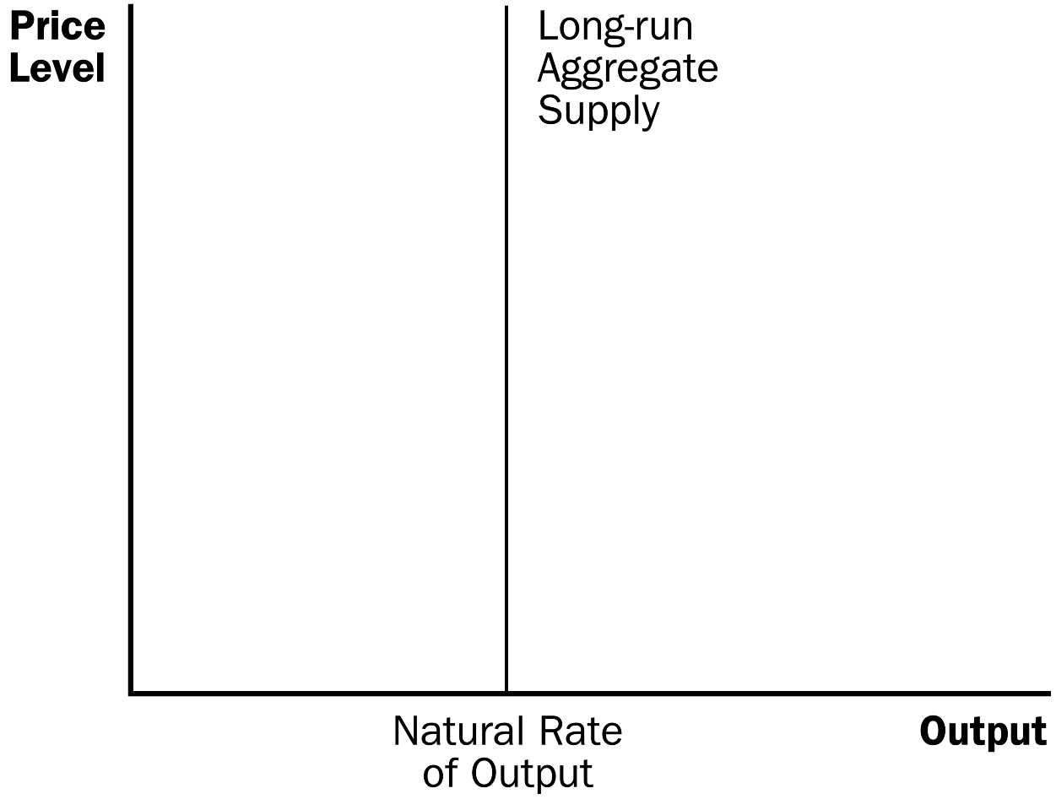

3. The vertical long-run aggregate-supply curve is a graphical representation of the classical dichotomy and monetary neutrality.

C. Why the Long-Run Aggregate-Supply Curve Might Shift

1. The position of the aggregate-supply curve occurs at an output level sometimes referred to as potential output or full-employment output.

2. Definition of natural level of output: the production of goods and services that an economy achieves in the long run when unemployment is at its natural rate.

3. Any change in the economy that alters the natural level of output shifts the long-run aggregate-supply curve.

4. Shifts Arising from Changes in Labor

a. Increases in immigration increase the number of workers available. The long-run aggregate-supply curve would shift to the right.

b. Any change in the natural rate of unemployment will alter long-run aggregate supply as well.

5. Shifts Arising from Changes in Capital

a. An increase in the economy’s capital stock raises productivity and thus shifts long-run aggregate supply to the right.

b. This would also be true if the increase occurred in human capital rather than physical capital.

6. Shifts Arising from Changes in Natural Resources

a. A discovery of a new mineral deposit shifts the long-run aggregate-supply curve to the right.

b. A change in weather patterns that makes farming more difficult shifts the long-run aggregate-supply curve to the left.

c. A change in the availability of imported resources (such as oil) can also affect long-run aggregate supply.

7. Shifts Arising from Changes in Technological Knowledge

a. The invention of the computer has allowed us to produce more goods and services from any given level of resources. As a result, it has shifted the long-run aggregate-supply curve to the right.

b. Opening up international trade has similar effects to inventing new production processes. Therefore, it also shifts the long-run aggregate-supply curve to the right.

D. Using Aggregate Demand and Aggregate Supply to Depict Long-Run Growth and Inflation

Figure 5

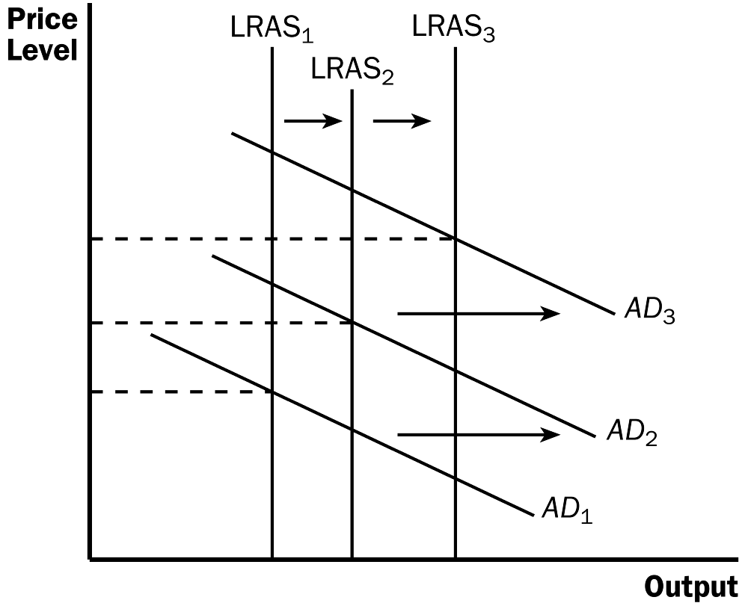

1. Two important forces that govern the economy in the long run are technological progress and monetary policy.

a. Technological progress shifts the long-run aggregate-supply curve to the right.

b. The Fed increases the money supply over time, which raises aggregate demand.

2. The result is growth in output and continuing inflation (increases in the price level).

3. Although the purpose of developing the model of aggregate demand and aggregate supply is to describe short-run fluctuations, these short-run fluctuations should be considered deviations from the long-run trends of output growth and inflation.

E. Why the Aggregate-Supply Curve Slopes Upward in the Short Run

1. In the short run, the price level does affect the economy's output. An increase in the overall level of prices tends to raise the quantity of goods and services supplied.

Figure 6

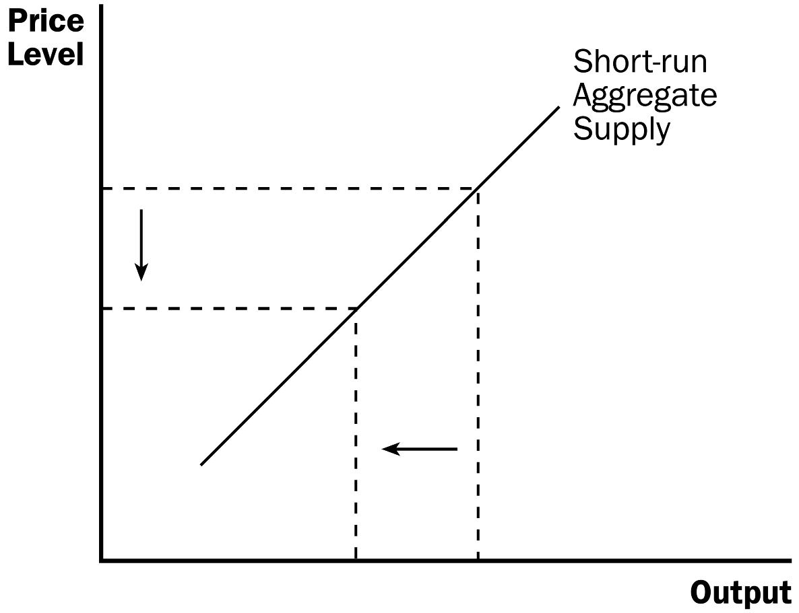

2. The quantity of output supplied deviates from its natural level when the actual price level deviates from the expected price level.

3. The Sticky-Wage Theory

a. Nominal wages are often slow to adjust to changing economic conditions due to long-term contracts between workers and firms along with social norms and notions of fairness that influence wage setting and are slow to change over time.

b. Example: Suppose a firm has agreed in advance to pay workers an hourly wage of $20 based on the expectation that the price level will be 100. If the price level is actually 95, the firm receives 5% less for its output than it expected and its labor costs are fixed at $20 per hour.

c. Production is now less profitable, so the firm hires fewer workers and reduces the quantity of output supplied.

d. Nominal wages are based on expected prices and do not adjust immediately when the actual price level differs from what is expected. This makes the short-run aggregate-supply curve upward sloping.

e. This theory of short-run aggregate supply is emphasized in the text.

4. The Sticky-Price Theory

a. The prices of some goods and services are also sometimes slow to respond to changing economic conditions. This is often blamed on menu costs.

b. If the price level falls unexpectedly, and a firm does not change the price of its product quickly, its relative price will rise and this will lead to a loss in sales.

c. Thus, when sales decline, firms will produce a lower quantity of goods and services.

d. Because not all prices adjust instantly to changing conditions, an unexpected fall in the price level leaves some firms with higher-than-desired prices, which depress sales and cause firms to reduce the quantity of goods and services supplied.

5. The Misperceptions Theory

a. Changes in the overall price level can temporarily mislead suppliers about what is happening in the markets in which they sell their output.

b. As a result of these misperceptions, suppliers respond to changes in the level of prices and thus, the short-run aggregate-supply curve is upward sloping.

c. Example: The price level falls unexpectedly. Suppliers mistakenly believe that as the price of their product falls, it is a drop in the relative price of their product. Suppliers may then believe that the reward of supplying their product has fallen, and thus they decrease the quantity that they supply. The same misperception may happen if workers see a decline in their nominal wage (caused by a fall in the price level).

d. Thus, a lower price level causes misperceptions about relative prices, and these misperceptions lead suppliers to respond to the lower price level by decreasing the quantity of goods and services supplied.

6. Note that each of these theories suggests that output deviates from its natural level when the price level deviates from the price level that people expected.

7. Note also that the effects of the change in the price level will be temporary. Eventually people will adjust their price level expectations and output will return to its natural level; thus, the aggregate-supply curve will be vertical in the long run.

8. Because the sticky-wage theory is the simplest of the three theories, it is the one that is emphasized in the text.

F. Summing Up

1. Economists debate which of these theories is correct and it is possible that each contains an element of truth.

2. All three theories suggest that output deviates in the short run from its long-run level when the actual price level deviates from the expected price level.

3. Each of the three theories emphasizes a problem that is likely to be temporary.

a. Over time, nominal wages will become unstuck, prices will become unstuck, and misperceptions about relative prices will be corrected.

b. In the long run, it is reasonable to assume that wages and prices are flexible and that people are not confused about relative prices.

G. Why the Short-Run Aggregate-Supply Curve Might Shift

1. Events that shift the long-run aggregate-supply curve will shift the short-run aggregate-supply curve as well.

2. However, expectations of the price level will affect the position of the short-run aggregate-supply curve even though it has no effect on the long-run aggregate-supply curve.

3. An increase in the expected price level decreases the quantity of goods and services supplied and shifts the short-run aggregate-supply curve to the left. A decrease in the expected price level increases the quantity of goods and services supplied and shifts the short-run aggregate-supply curve to the right.

Table 2

VI. Two Causes of Economic Fluctuations

A. Long-Run Equilibrium

Figure 7

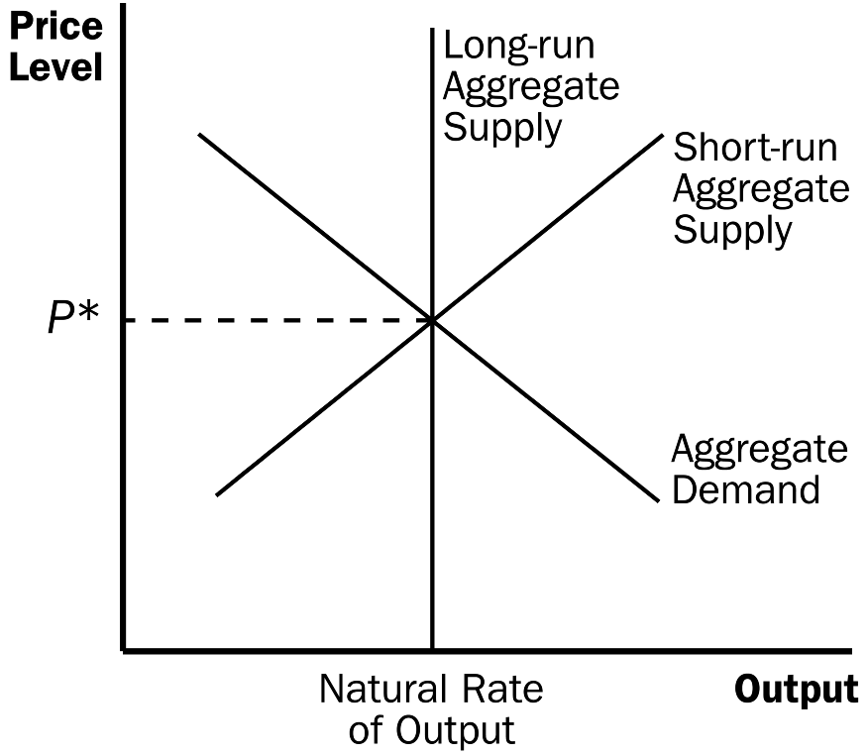

1. Long-run equilibrium is found where the aggregate-demand curve intersects with the long-run aggregate-supply curve.

2. Output is at its natural level.

3. Also at this point, perceptions, wages, and prices have all adjusted so that the short-run aggregate-supply curve intersects at this point as well.

B. The Effects of a Shift in Aggregate Demand

Table 3

Students will be confused by the graphs showing the adjustment process that occurs when aggregate demand shifts. Take the time to walk them through step-by-step several times, summarizing what moves the economy from one point to the next.

1. Example: Pessimism causes household spending and investment to decline.

2. This will cause the aggregate-demand curve to shift to the left.

3. In the short run, both output and the price level fall. This drop in output means that the economy is in a recession.

4. In the long run, the economy will move back to the natural rate of output.

a. People will correct the misperceptions, sticky wages, and sticky prices that cause the aggregate-supply curve to be upward sloping in the short run.

b. The expected price level will fall, shifting the short-run aggregate-supply curve to the right.

Figure 8
Price
Level
Output
Long-Run Aggregate Supply
AD₁
AD₂
AS₁
AS₂

5. In the long run, the decrease in aggregate demand can be seen solely by the drop in the equilibrium price level. Thus, the long-run effect of a change in aggregate demand is a nominal change (in the price level) but not a real change (output is the same).

6. Instead of waiting for the economy to adjust on its own, policymakers may want to eliminate the recession by boosting government spending or increasing the money supply. Either way, these policies could shift the aggregate demand curve back to the right.

7. FYI: Monetary Neutrality Revisited

a. According to classical theory, changes in the quantity of money affect nominal variables such as the price level, but not real variables such as output.

b. If the Fed decreases the money supply, aggregate demand shifts to the left. In the short run, output and the price level decline. After expectations, prices, and wages have adjusted, the economy finds itself back on the long-run aggregate-supply curve at the natural level of output.

c. Thus, changes in the money supply have effects on real output in the short run only.

8. Case Study: Two Big Shifts in Aggregate Demand: The Great Depression and World War II

a. Figure 9 shows real GDP for the United States since 1900.

Figure 9

b. Two time periods of economic fluctuations can be seen dramatically in the picture. These are the early 1930s (the Great Depression) and the early 1940s (World War II).

c. From 1929 to 1933, GDP fell by 27%. From 1939 to 1944, the economy’s production of goods and services almost doubled.

9. Case Study: The Recession of 2008–2009

a. The United States experienced a financial crisis and severe economic downturn in 2008 and 2009.

b. The recession was preceded by a housing boom fueled by low interest rates and various developments in the mortgage market.

c. From 2006 to 2009, housing values in the U.S. fell by 30%. This led to substantial defaults, causing additional large losses in the values of mortgage-backed securities.

d. The economy experienced a large drop in aggregate demand causing real GDP to fall and unemployment to rise.

10. In the News: What have we learned?

a. Following the financial crisis and deep recession of 2008-2009, economists are learning lessons about macroeconomics.

b. This article from The Wall Street Journal describes five important lessons.

C. The Effects of a Shift in Aggregate Supply

1. Example: Firms experience a sudden increase in their costs of production.

2. This will cause the short-run aggregate-supply curve to shift to the left. (Depending on the event, long-run aggregate supply may also shift. We will assume that it does not.)

3. In the short run, output will fall and the price level will rise. The economy is experiencing stagflation.

4. Definition of stagflation: a period of falling output and rising prices.

Figure 10

Price
Level
Long-Run Aggregate Supply

AS₂

AS₁

P*₂

P*₁

AD

Output

5. The result over time may be a wage-price spiral.

6. Eventually, the low level of output will put downward pressure on wages.

a. Producing goods and services becomes more profitable.

b. Short-run aggregate supply shifts to the right until the economy is again producing at the natural level of output.

7. If policymakers want to end the stagflation, they can shift the aggregate-demand curve. Note that they cannot simultaneously offset the drop in output and the rise in the price level. If they increase aggregate demand, the recession will end, but the price level will be permanently higher.

Figure 11

8. Case Study: Oil and the Economy

a. Crude oil is a key input in the production of many goods and services.

b. When some event (often political) leads to a rise in the price of crude oil, firms must endure higher costs of production and the short-run aggregate-supply curve shifts to the left.

c. In the mid-1970s, OPEC lowered production of oil and the price of crude oil rose substantially. The inflation rate in the United States was pushed to over 10%. Unemployment also grew from 4.9% in 1973 to 8.5% in 1975.

d. This occurred again in the late 1970s. Oil prices rose, output fell, and the rate of inflation increased.

e. In the late 1980s, OPEC began to lose control over the oil market as members began cheating on the agreement. Oil prices fell, which led to a rightward shift of the short-run aggregate-supply curve. This caused both unemployment and inflation to decline.

9. FYI: The Origins of the Model of Aggregate Demand and Aggregate Supply

a. The AD/AS model is a by-product of the Great Depression.

b. In 1936, economist John Maynard Keynes published a book that attempted to explain short-run fluctuations.

c. Keynes believed that recessions occur because of inadequate demand for goods and services.

d. Therefore, Keynes advocated policies to increase aggregate demand.

Activity 1—National Output Article

Type: Take-home assignment
Topics: Fluctuations in output and the price level
Class limitations: Works in any class

Purpose
This assignment is a good way for students to connect economic theory to actual events.

Assignment
1. Find an article in a recent newspaper or magazine illustrating a change that will affect national output.
2. Analyze the situation using economic reasoning.
3. Draw an aggregate demand and aggregate supply graph to explain this change. Be sure to label your graph and clearly indicate which curve shifts. Explain what happens to national income and to the price level in the short run.
4. Turn in a copy of the article along with your explanation.

Points for Discussion
This can be a nice way to review the elements of aggregate demand (consumption, investment, government spending, and net exports) and the elements of aggregate supply (productive resources, technology).

Most changes will only shift one curve.

Discussing the long-run impact of these changes can emphasize the differences between AS and AD shifts.

Activity 2—The Economics of War

Type: In-class assignment
Topics: National income, price levels, total spending, resources
Materials needed: None
Time: 20 minutes
Class limitations: Works in any size class

Purpose
This assignment asks students to examine their beliefs about the impact of war on the economy. It can be used to examine aggregate demand shifts and aggregate supply shifts. This assignment can generate lively discussion.

Instructions
Ask the class to answer the following questions. Give them time to write an answer to a question, then discuss their answers before moving to the next question.
1. Is war good or bad for the economy?
2. What are the opportunity costs of using resources in wars?
3. How would a war affect aggregate supply?
4. Graph the shift in aggregate supply. What happens to output and the price level?
5. How would a war affect aggregate demand?
6. Graph the shift in aggregate demand. What happens to output and the price level?
7. Is peace good or bad for the economy?

SOLUTIONS TO TEXT PROBLEMS:

Quick Quizzes

1. Three key facts about economic fluctuations are: (1) economic fluctuations are irregular and unpredictable; (2) most macroeconomic quantities fluctuate together; and (3) as output falls, unemployment rises.

Economic fluctuations are irregular and unpredictable, as you can see by looking at a graph of real GDP over time. Some recessions are close together and others are far apart. There appears to be no recurring pattern.

Most macroeconomic quantities fluctuate together. In recessions, real GDP, consumer spending, investment spending, corporate profits, and other macroeconomic variables decline or grow much more slowly than during economic expansions. However, the variables fluctuate by different amounts over the business cycle, with investment varying much more than other variables.

As output falls, unemployment rises, because when firms want to produce less, they lay off workers, thus causing a rise in unemployment.

2. The economy’s behavior in the short run differs from its behavior in the long run because the assumption of monetary neutrality applies only to the long run, not the short run. In the short run, real and nominal variables are highly intertwined.
Figure 1 shows the model of aggregate demand and aggregate supply. The horizontal axis shows the quantity of output, and the vertical axis shows the price level.

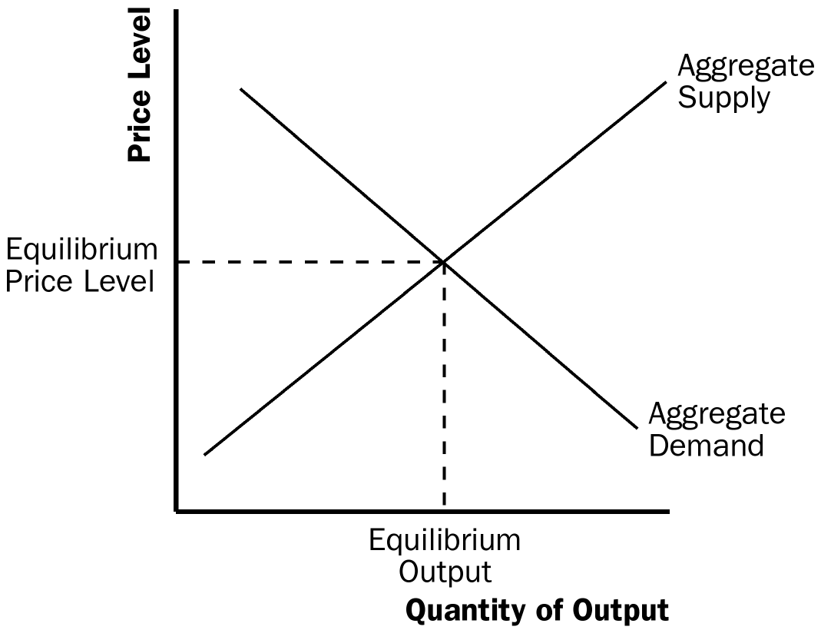

Figure 1

3. The aggregate-demand curve slopes downward for three reasons. First, when prices fall, the value of dollars in people’s wallets and bank accounts rises, so they feel wealthier. As a result, they spend more, thereby increasing the quantity of goods and services demanded. Second, when prices fall, people need less money to make their purchases, so they lend more out, which reduces the interest rate. The lower interest rate encourages businesses to invest more, increasing the quantity of goods and services demanded. Third, since lower prices lead to a lower interest rate, some U.S. investors will invest abroad, supplying dollars to the foreign-exchange market, thus causing the dollar to depreciate. The decline in the real exchange rate causes net exports to increase, which increases the quantity of goods and services demanded.

Any event that alters the level of consumption, investment, government purchases, or net exports at a given price level will lead to a shift in aggregate demand. An increase in expenditure will shift the aggregate-demand curve to the right, while a decline in expenditure will shift the aggregate-demand curve to the left.

4. The long-run aggregate-supply curve is vertical because the price level does not affect the long-run determinants of real GDP, which include supplies of labor, capital, natural resources, and the level of available technology. This is an application of the classical dichotomy and monetary neutrality.

There are three reasons the short-run aggregate-supply curve slopes upward. First, the sticky-wage theory suggests that because nominal wages are slow to adjust, a decline in the price level means real wages are higher, so firms hire fewer workers and produce less, causing the quantity of goods and services supplied to decline. Second, the sticky-price theory suggests that the prices of some goods and services are slow to change. If some economic event causes the overall price level to decline, the relative prices of goods whose prices are sticky will rise and the quantity of those goods sold will decline, leading firms to cut back on production. Thus, a lower price level reduces the quantity of goods and services supplied. Third, the misperceptions theory suggests that changes in the overall price level can temporarily mislead suppliers. When the price level falls below the level that was expected, suppliers think that the relative prices of their products have declined, so they produce less. Thus, a lower price level reduces the quantity of goods and services supplied.

The long-run and short-run aggregate-supply curves will both shift if the supplies of labor, capital, or natural resources change or if technology changes. A change in the expected price level will shift the short-run aggregate-supply curve but will have no effect on the long-run aggregate-supply curve.

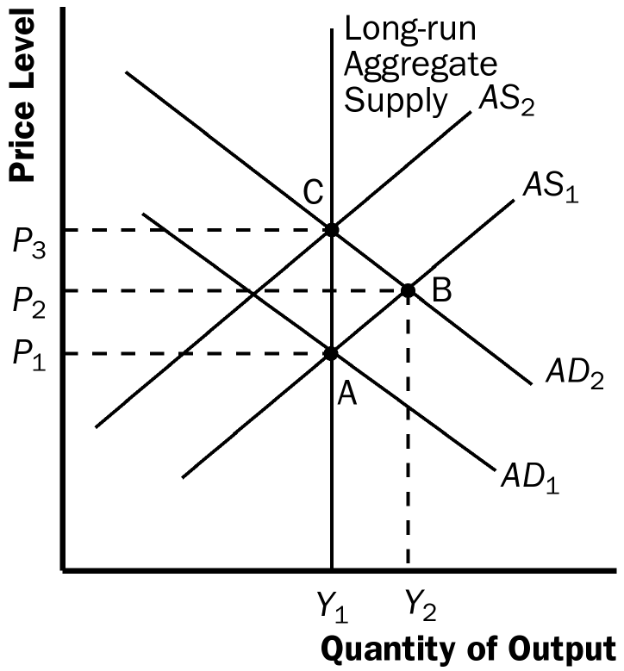

Figure 2

5. When a popular presidential candidate is elected, causing people to be more confident about the future, they will spend more, causing the aggregate-demand curve to shift to the right, as shown in Figure 2. The economy begins at point A with aggregate-demand curve AD₁ and short-run aggregate-supply curve AS₁. The equilibrium has price level P₁ and output level Y₁. Increased confidence about the future causes the aggregate-demand curve to shift to AD₂. The economy moves to point B, with price level P₂ and output level Y₂. Over time, price expectations adjust and the short-run aggregate-supply curve shifts to the left to AS₂ and the economy moves to equilibrium at point C, with price level P₃ and output level Y₁.

Questions for Review

1. Two macroeconomic variables that decline when the economy goes into a recession are real GDP and investment spending (many other answers are possible). A macroeconomic variable that rises during a recession is the unemployment rate.

2. Figure 3 shows aggregate demand, short-run aggregate supply, and long-run aggregate supply.
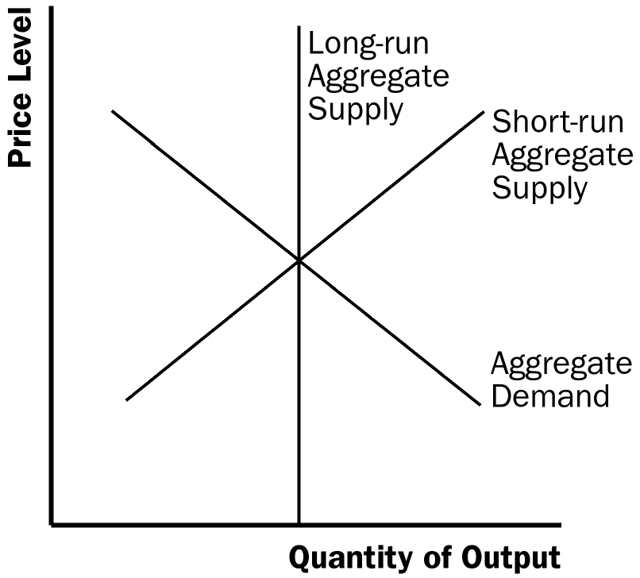

Figure 3

3. The aggregate-demand curve slopes downward because: (1) a decrease in the price level makes consumers feel wealthier, which in turn encourages them to spend more, so there is a larger quantity of goods and services demanded; (2) a lower price level reduces the interest rate, encouraging greater spending on investment, so there is a larger quantity of goods and services demanded; (3) a fall in the U.S. price level causes U.S. interest rates to fall, so the real exchange rate depreciates, stimulating U.S. net exports, so there is a larger quantity of goods and services demanded.

4. The long-run aggregate supply curve is vertical because in the long run, an economy's supply of goods and services depends on its supplies of capital, labor, and natural resources and on the available production technology used to turn these resources into goods and services. The price level does not affect these long-run determinants of real GDP.

5. Three theories explain why the short-run aggregate-supply curve slopes upward: (1) the sticky-wage theory, in which a lower price level makes employment and production less profitable because wages do not adjust immediately to the price level, so firms reduce the quantity of goods and services supplied; (2) the sticky-price theory, in which an unexpected fall in the price level leaves some firms with higher-than-desired prices because not all prices adjust instantly to changing conditions, which depresses sales and induces firms to reduce the quantity of goods and services they produce; and (3) the misperceptions theory, in which a lower price level causes misperceptions about relative prices, and these misperceptions induce suppliers to respond to the lower price level by decreasing the quantity of goods and services supplied.

6. The aggregate-demand curve might shift to the left when something (other than a rise in the price level) causes a reduction in consumption spending (such as a desire for increased saving), a reduction in investment spending (such as increased taxes on the returns to investment), decreased government spending (such as a cutback in defense spending), or reduced net exports (such as when foreign economies go into recession).

Figure 4 traces through the steps of such a shift in aggregate demand. The economy begins in equilibrium, with short-run aggregate supply, AS₁, intersecting aggregate demand, AD₁, at point A. When the aggregate-demand curve shifts to the left to AD₂, the economy moves from point A to point B, reducing the price level and the quantity of output. Over time, people adjust their perceptions, wages, and prices, shifting the short-run aggregate-supply curve to the right to AS₂, and moving the economy from point B to point C, which is back on the long-run aggregate-supply curve and has a lower price level.

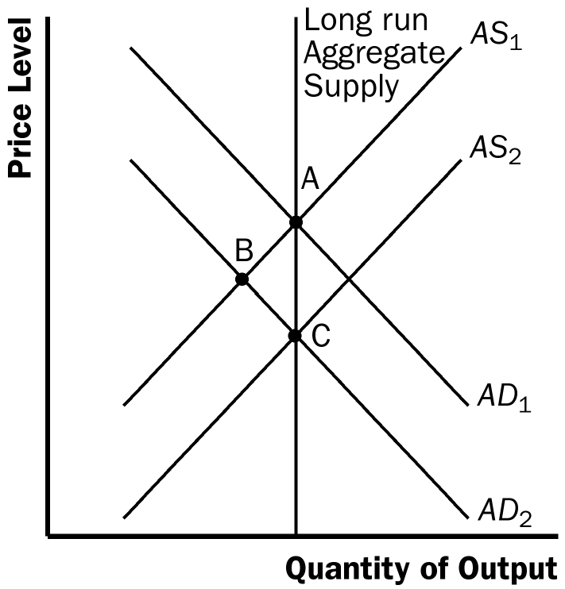

Figure 4

7. The aggregate-supply curve might shift to the left because of a decline in the economy's capital stock, labor supply, or productivity, or an increase in the natural rate of unemployment, all of which shift both the long-run and short-run aggregate-supply curves to the left. An increase in the expected price level shifts just the short-run aggregate-supply curve (not the long-run aggregate-supply curve) to the left.

Figure 5 traces through the effects of a shift in short-run aggregate supply. The economy starts in equilibrium at point A. The aggregate-supply curve shifts to the left from AS₁ to AS₂. The new equilibrium is at point B, the intersection of the aggregate-demand curve and AS₂. As time goes on, perceptions and expectations adjust and the economy returns to long-run equilibrium at point A, because the short-run aggregate-supply curve shifts back to its original position.

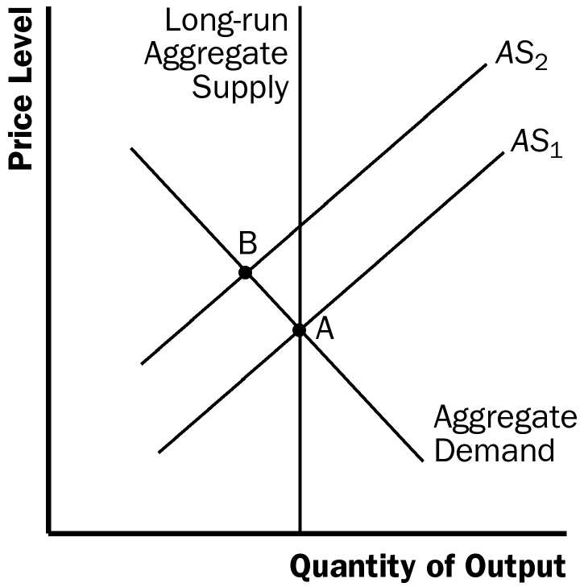

Figure 5

Quick Check Multiple Choice

1. c

2. a

3. b

4. a

5. c

6. d

Problems and Applications
Price
Level
Output
Long-Run Aggregate Supply
AD₁
AD₂
AS₁
AS₂

Figure 6

1. a. The current state of the economy is shown in Figure 6. The aggregate-demand curve (AD₁) and short-run aggregate-supply curve (AS₁) intersect at the same point on the long-run aggregate-supply curve.

b. A stock market crash leads to a leftward shift of aggregate demand (to AD₂). The equilibrium level of output and the price level will fall. Because the quantity of output is less than the natural level of output, the unemployment rate will rise above the natural rate of unemployment.

c. If nominal wages are unchanged as the price level falls, firms will be forced to cut back on employment and production. Over time as expectations adjust, the short-run aggregate-supply curve will shift to the right (to AS₂), moving the economy back to the natural level of output.

2. a. When the United States experiences a wave of immigration, the labor force increases, so long-run aggregate supply shifts to the right.

b. When Congress raises the minimum wage to $10 per hour, the natural rate of unemployment rises, so the long-run aggregate-supply curve shifts to the left.

c. When Intel invents a new and more powerful computer chip, productivity increases, so long-run aggregate supply increases because more output can be produced with the same inputs.

d. When a severe hurricane damages factories along the East Coast, the capital stock is smaller, so long-run aggregate supply declines.

3. a. The current state of the economy is shown in Figure 7. The aggregate-demand curve and short-run aggregate-supply curve intersect at the same point on the long-run aggregate-supply curve.

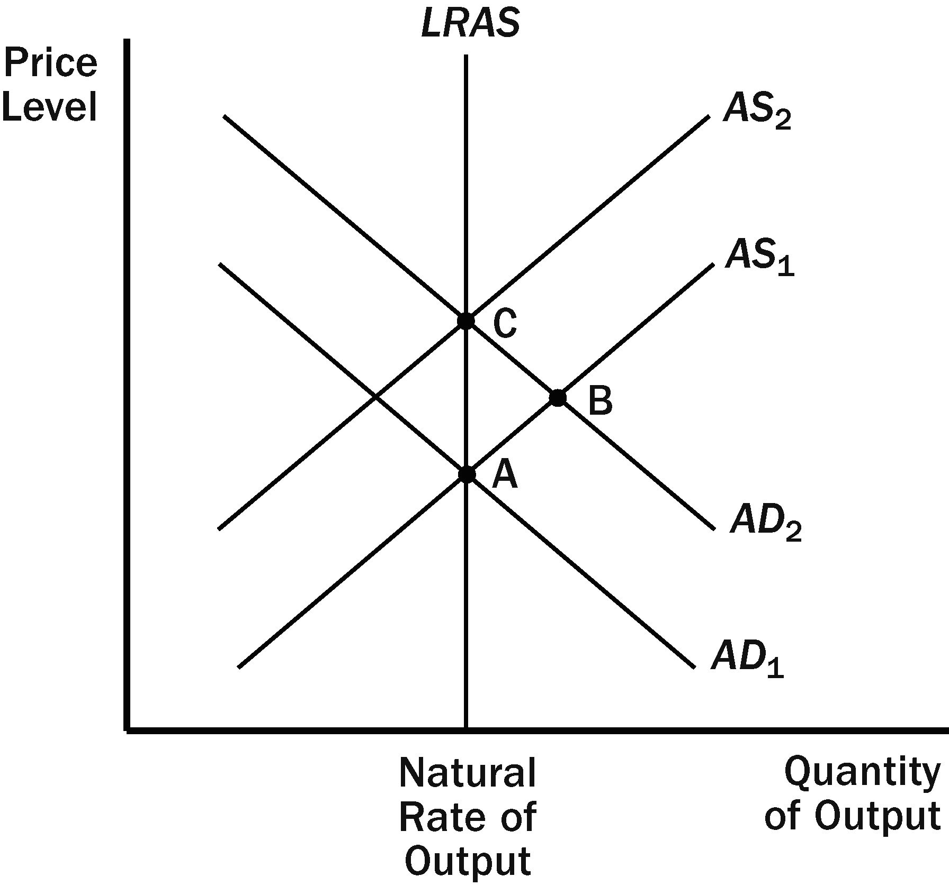

Figure 7

b. If the central bank increases the money supply, aggregate demand shifts to the right (to point B). In the short run, there is an increase in output and the price level.

c. Over time, nominal wages, prices, and perceptions will adjust to this new price level. As a result, the short-run aggregate-supply curve will shift to the left. The economy will return to its natural level of output (point C).

d. According to the sticky-wage theory, nominal wages at points A and B are equal. However, nominal wages at point C are higher than at point A.

e. According to the sticky-wage theory, real wages at point B are lower than real wages at point A. However, real wages at points A and C are equal.

f. Yes, this analysis is consistent with long-run monetary neutrality. In the long run, an increase in the money supply causes an increase in the nominal wage, but leaves the real wage unchanged.

4. During the Great Depression, equilibrium output (Y₁) was lower than the natural level of output (Y₂). The idea of lengthening the shopping period between Thanksgiving and Christmas was to increase aggregate demand. As Figure 8 shows, this could increase output back to its long-run equilibrium level (Y₂).

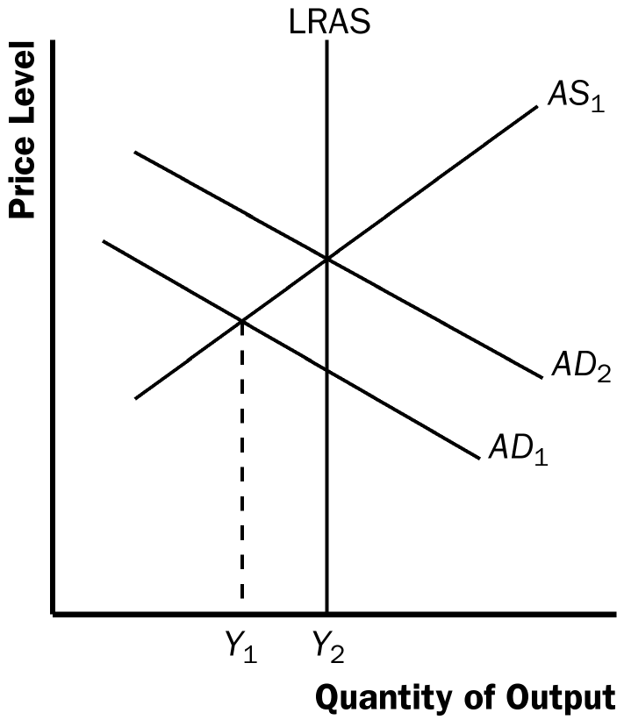

Figure 8

5. a. The statement that "the aggregate-demand curve slopes downward because it is the horizontal sum of the demand curves for individual goods" is false. The aggregate-demand curve slopes downward because a fall in the price level raises the overall quantity of goods and services demanded through the wealth effect, the interest-rate effect, and the exchange-rate effect.

b. The statement that "the long-run aggregate-supply curve is vertical because economic forces do not affect long-run aggregate supply" is false. Economic forces of various kinds (such as population and productivity) do affect long-run aggregate supply. The long-run aggregate-supply curve is vertical because the price level does not affect long-run aggregate supply.

c. The statement that "if firms adjusted their prices every day, then the short-run aggregate-supply curve would be horizontal" is false. If firms adjusted prices quickly and if sticky prices were the only possible cause for the upward slope of the short-run aggregate-supply curve, then the short-run aggregate-supply curve would be vertical, not horizontal. The short-run aggregate supply curve would be horizontal only if prices were completely fixed.

d. The statement that "whenever the economy enters a recession, its long-run aggregate-supply curve shifts to the left" is false. An economy could enter a recession if either the aggregate-demand curve or the short-run aggregate-supply curve shifts to the left.

6. a. According to the sticky-wage theory, the economy is in a recession because the price level has declined so that real wages are too high, thus labor demand is too low. Over time, as nominal wages are adjusted so that real wages decline, the economy returns to full employment.

According to the sticky-price theory, the economy is in a recession because not all prices adjust quickly. Over time, firms are able to adjust their prices more fully, and the economy returns to the long-run aggregate-supply curve.

According to the misperceptions theory, the economy is in a recession when the price level is below what was expected. Over time, as people observe the lower price level, their expectations adjust, and the economy returns to the long-run aggregate-supply curve.

b. The speed of the recovery in each theory depends on how quickly price expectations, wages, and prices adjust.

7. a. People will likely expect that the new chairman will not actively fight inflation so they will expect the price level to rise.

b. If people believe that the price level will be higher over the next year, workers will want higher nominal wages.

c. At any given price level, higher labor costs lead to reduced profitability.

d. The short-run aggregate-supply curve will shift to the left as shown in Figure 9.

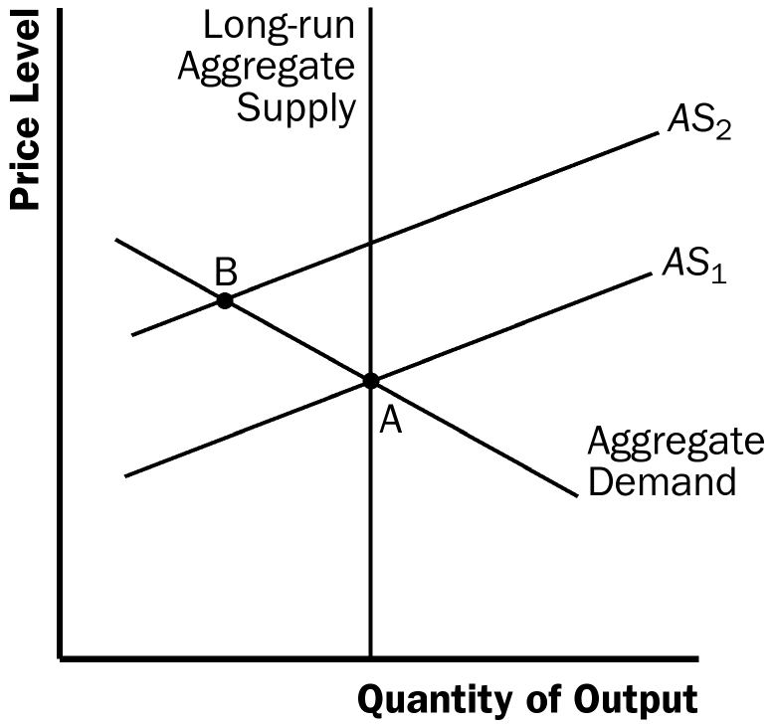

Figure 9

e. A decline in short-run aggregate supply leads to reduced output and a higher price level.

f. No, this choice was probably not wise. The end result is stagflation, which provides limited choices in terms of policies to remedy the situation.

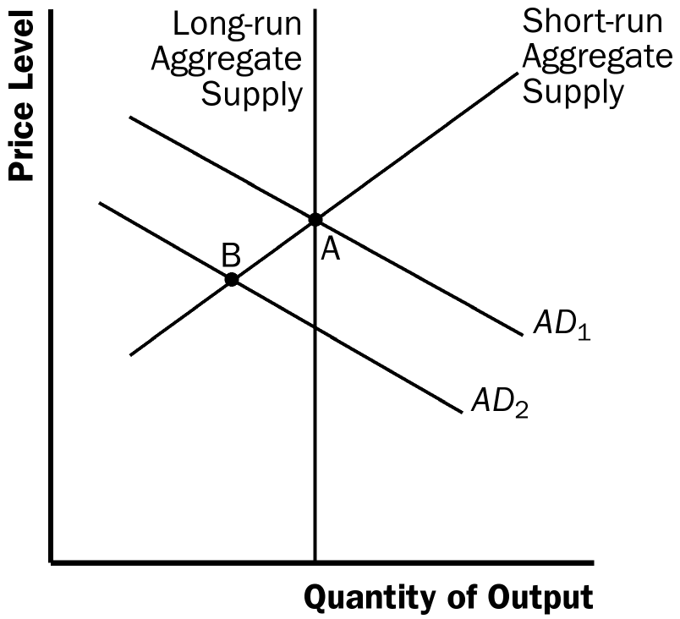

Figure 10

8. a. If households decide to save a larger share of their income, they must spend less on consumer goods, so the aggregate-demand curve shifts to the left, as shown in Figure 10. The equilibrium changes from point A to point B, so the price level declines and output declines.

b. If Florida orange groves suffer a prolonged period of below-freezing temperatures, the orange harvest will be reduced. This decline in the natural level of output is represented in Figure 11 by a shift to the left in both the short-run and long-run aggregate-supply curves. The equilibrium changes from point A to point B, so the price level rises and output declines.

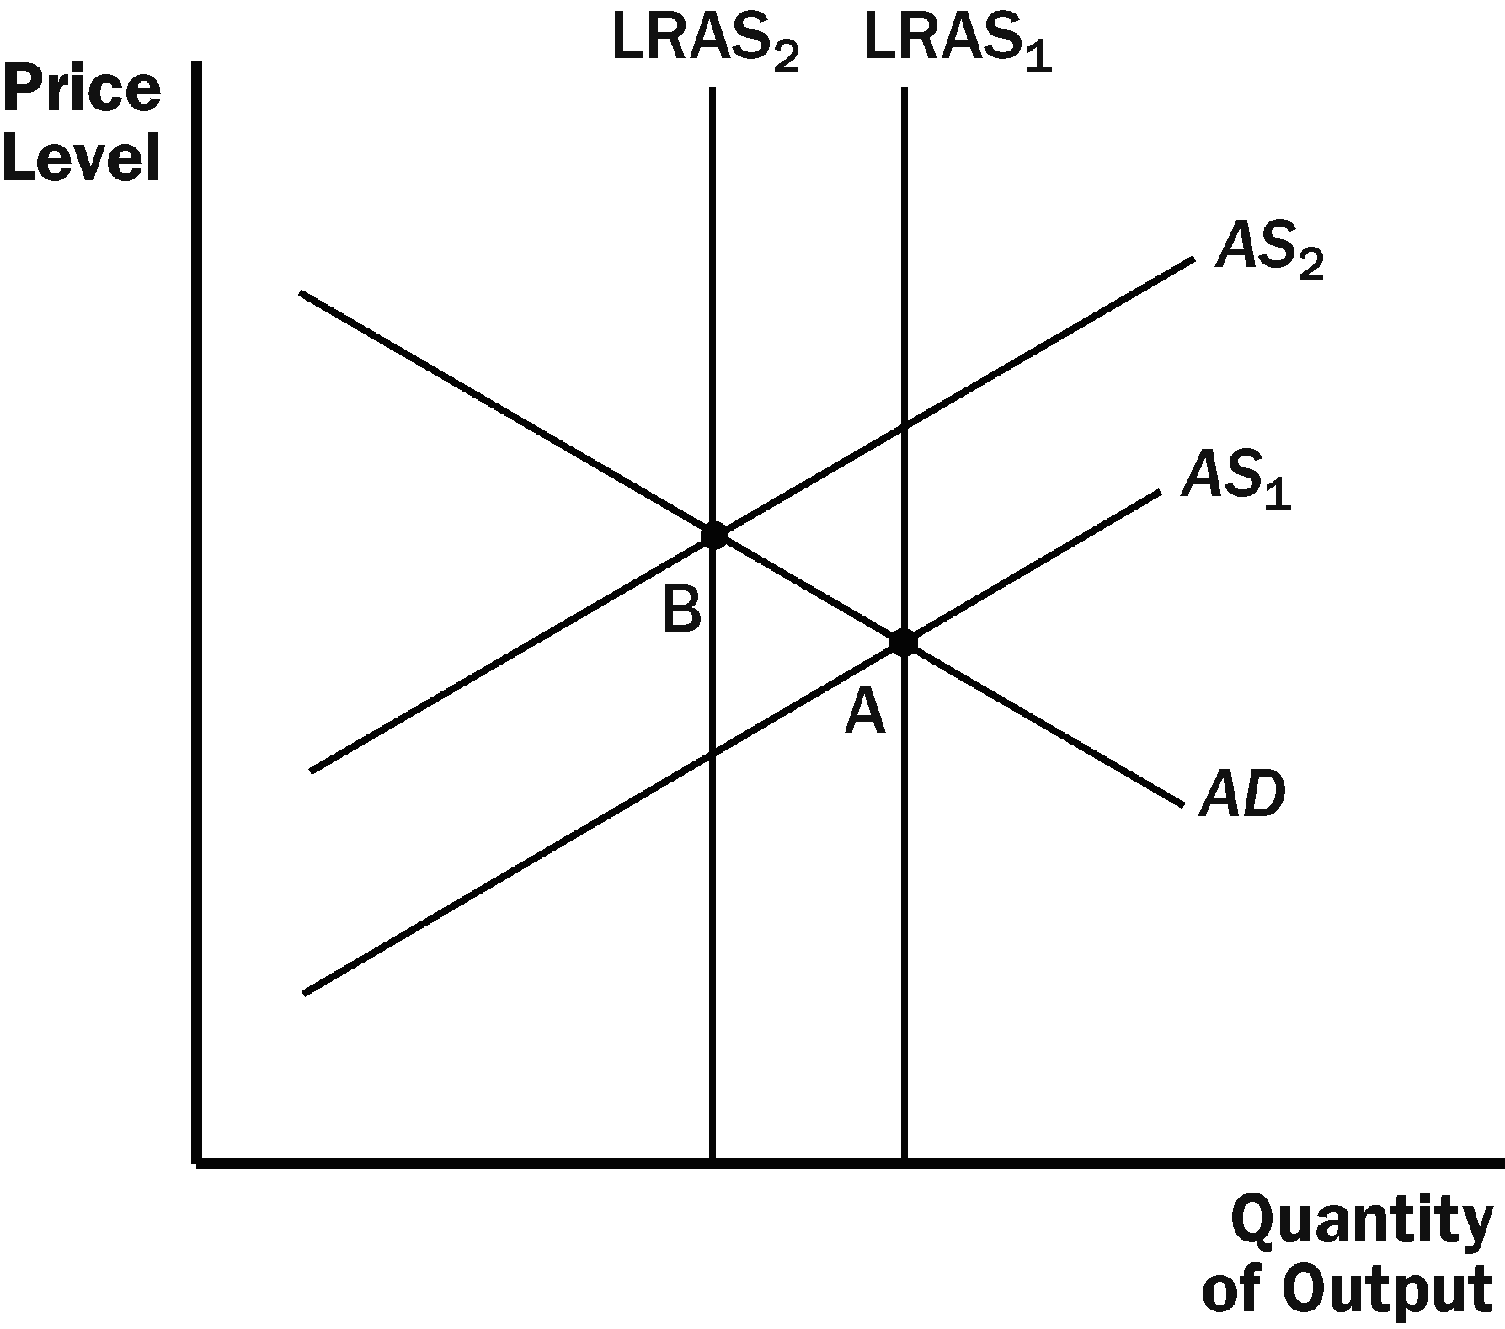

Figure 11

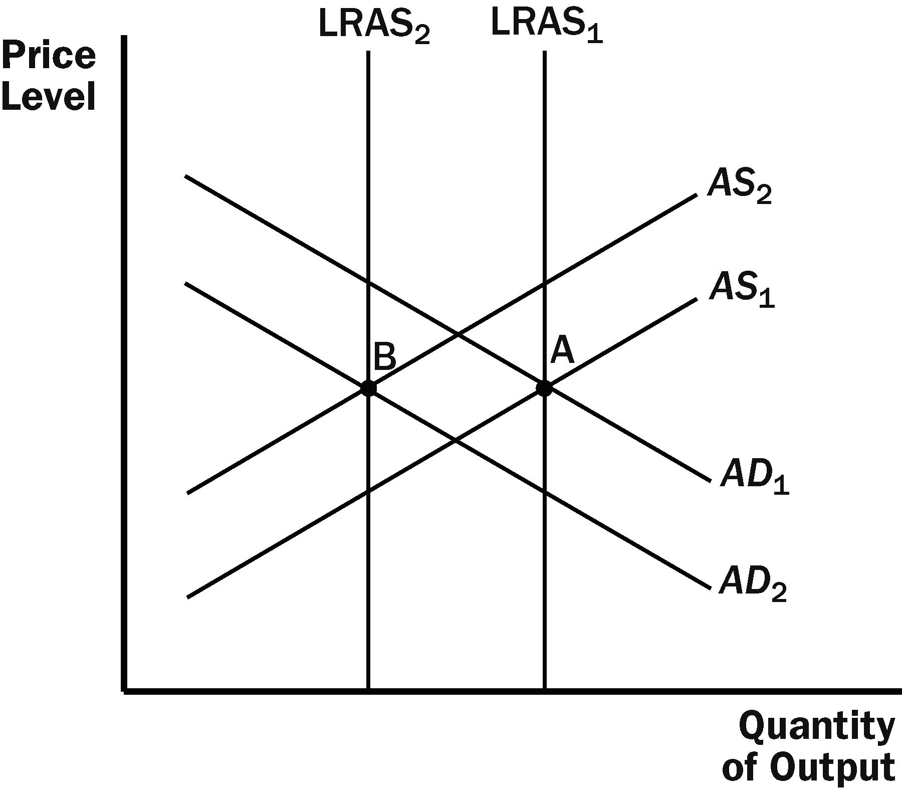

Figure 12

c. If increased job opportunities cause people to leave the country, the long-run and short-run aggregate-supply curves will shift to the left because there are fewer people producing output. The aggregate-demand curve will also shift to the left because there are fewer people consuming goods and services. The result is a decline in the quantity of output, as Figure 12 shows. Whether the price level rises or declines depends on the relative sizes of the shifts in the aggregate-demand curve and the aggregate-supply curves.

9. a. When the stock market declines sharply, wealth declines, so the aggregate-demand curve shifts to the left, as shown in Figure 13. In the short run, the economy moves from point A to point B, as output declines and the price level declines. In the long run, the short-run aggregate-supply curve shifts to the right to restore equilibrium at point C, with unchanged output and a lower price level compared to point A.

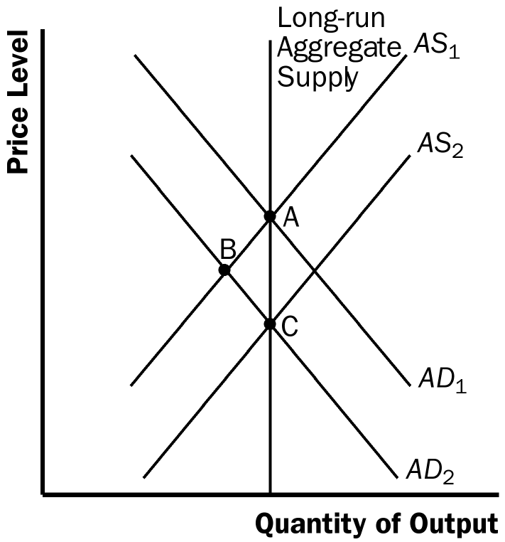

Figure 13
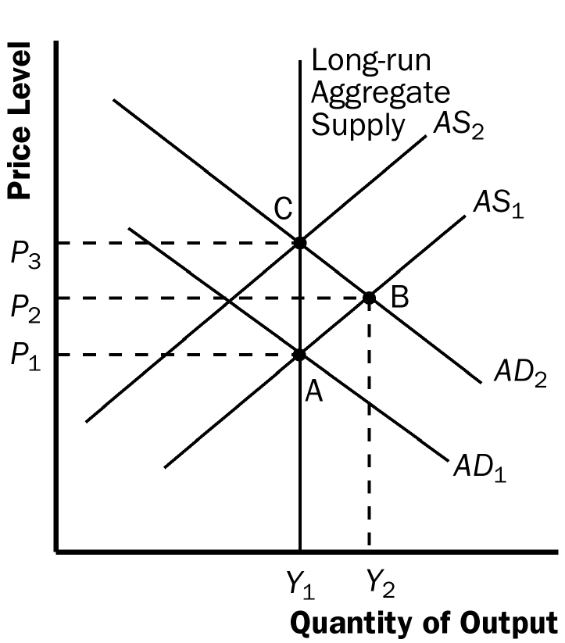

Figure 14

b. When the federal government increases spending on national defense, the rise in government purchases shifts the aggregate-demand curve to the right, as shown in Figure 14. In the short run, the economy moves from point A to point B, as output and the price level rise. In the long run, the short-run aggregate-supply curve shifts to the left to restore equilibrium at point C, with unchanged output and a higher price level compared to point A.

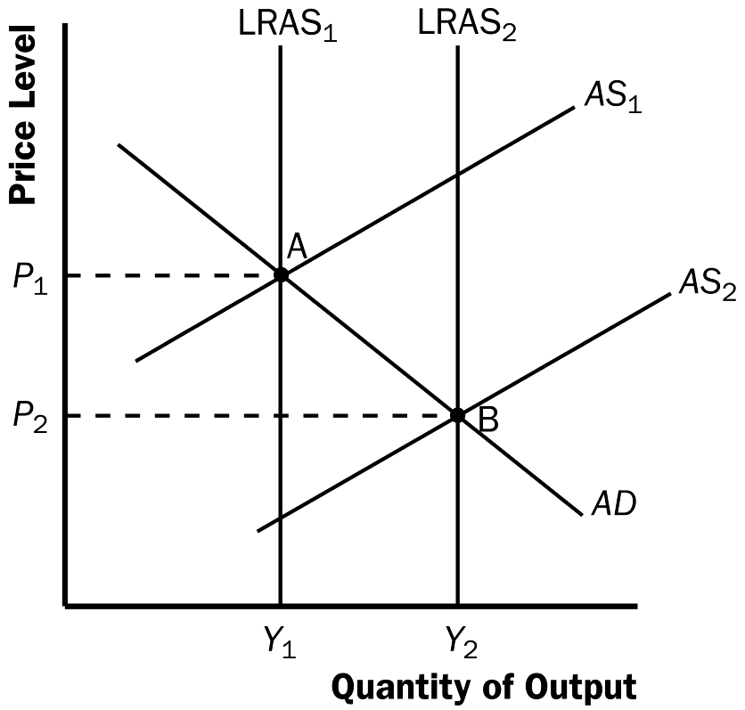

Figure 15

c. When a technological improvement raises productivity, the long-run and short-run aggregate-supply curves shift to the right, as shown in Figure 15. The economy moves from point A to point B, as output rises and the price level declines.

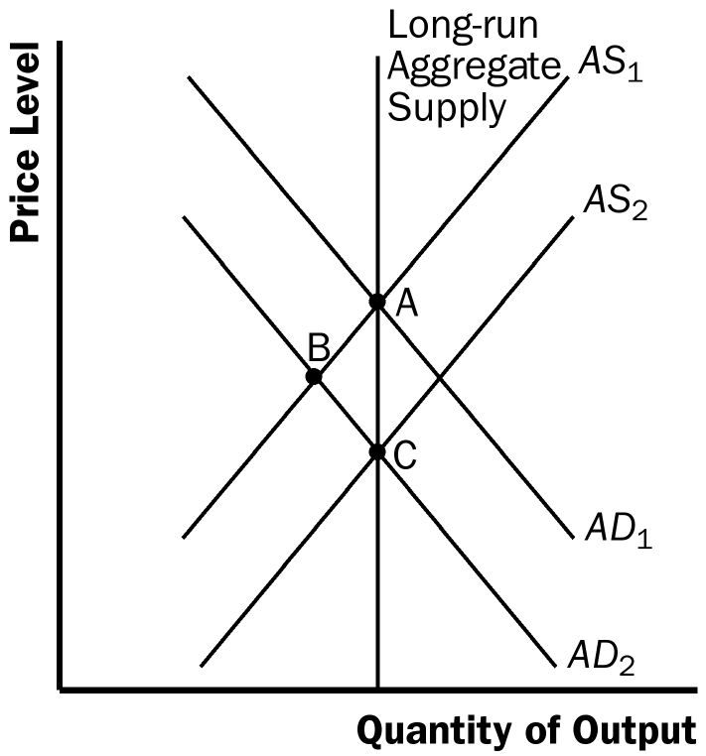

Figure 16

d. When a recession overseas causes foreigners to buy fewer U.S. goods, net exports decline, so the aggregate-demand curve shifts to the left, as shown in Figure 16. In the short run, the economy moves from point A to point B, as output declines and the price level declines. In the long run, the short-run aggregate-supply curve shifts to the right to restore equilibrium at point C, with unchanged output and a lower price level compared to point A.

10. a. If firms become optimistic about future business conditions and increase investment, the result is shown in Figure 17. The economy begins at point A with aggregate-demand curve AD₁ and short-run aggregate-supply curve AS₁. The equilibrium has price level P₁ and output level Y₁. Increased optimism leads to greater investment, so the aggregate-demand curve shifts to AD₂. Now the economy is at point B, with price level P₂ and output level Y₂. The aggregate quantity of output supplied rises because the price level has risen and people have misperceptions about the price level, wages are sticky, or prices are sticky, all of which cause output supplied to increase.
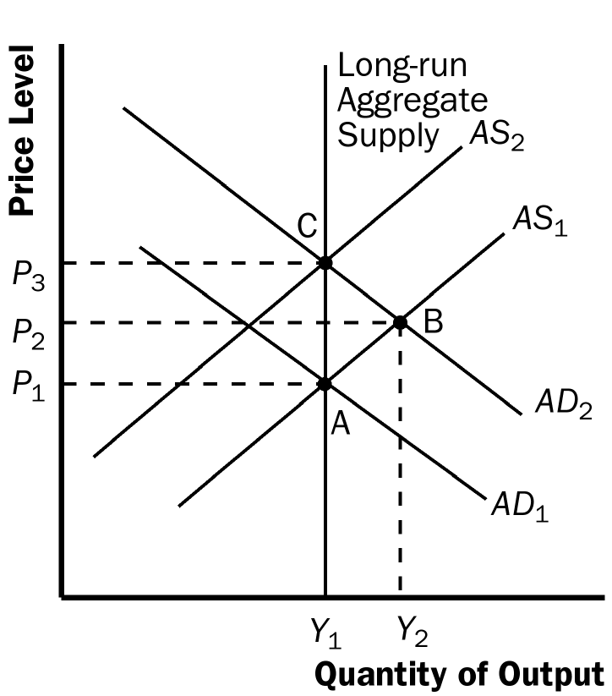

Figure 17

b. Over time, as the misperceptions of the price level disappear, wages adjust, or prices adjust, the short-run aggregate-supply curve shifts to the left to AS₂ and the economy gets to equilibrium at point C, with price level P₃ and output level Y₁. The quantity of output demanded declines as the price level rises.

c. The investment boom might increase the long-run aggregate-supply curve because higher investment today means a larger capital stock in the future, thus higher productivity and output.

